Model question of calculus-I F.M: 100

P.M: 45

ATTEMPT ALL QUESTIONS

1(a) Define the continuity of the function f(x) at x=a.what value should be assigned to the constant ‘a’ to make the function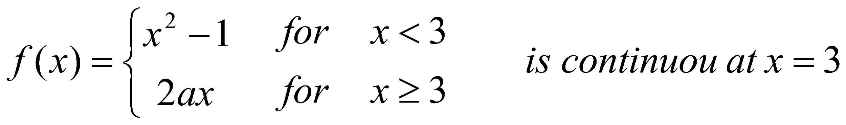 [7]

(b) show that every differentiable function is continuous but converse may not always ture [8]

Or

If 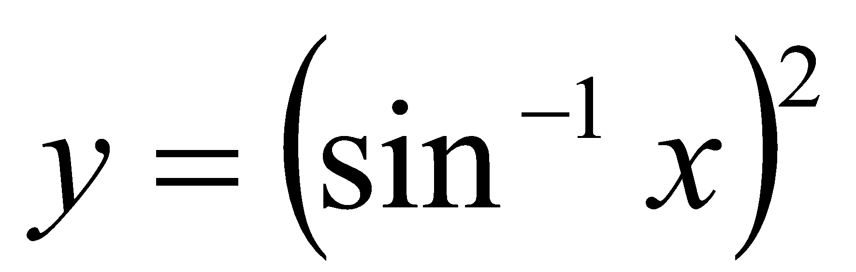prove that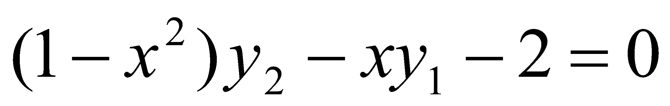 and hence show that 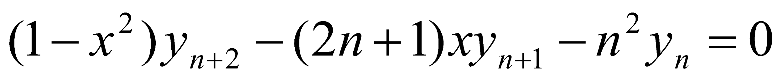

2(a) State the mean value theorem also interprete geometrically.Verify Rolles theorem for the function f(x)=Ax2+Bx+C In (a,b) [8]

(b)Find the asymptotes of the curve  [7]

Or

Trace the curve x=a(t+sint) ,y=a(1+cost)

3. Attempt any three question {3\*5=15}

(a) Prove that 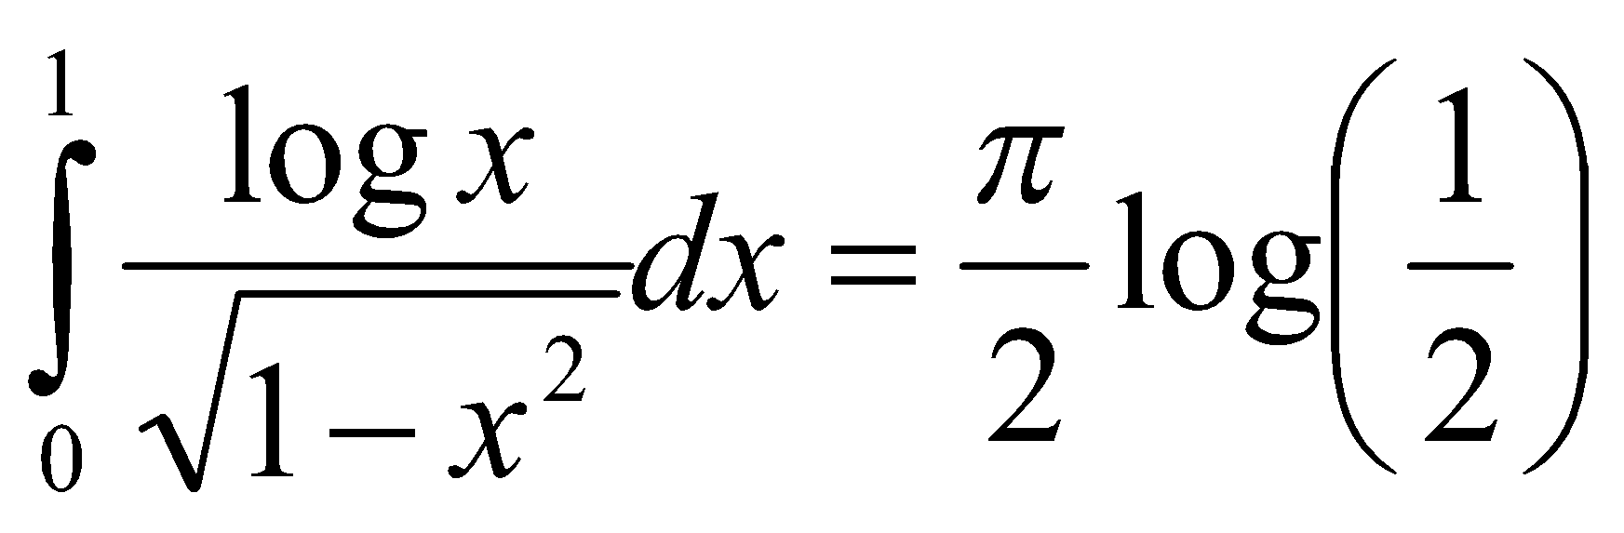

(b) Prove that 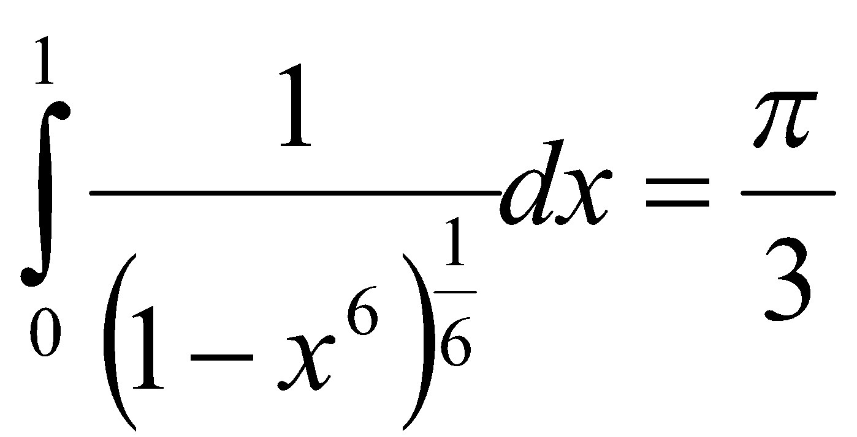

(c) Evaluate 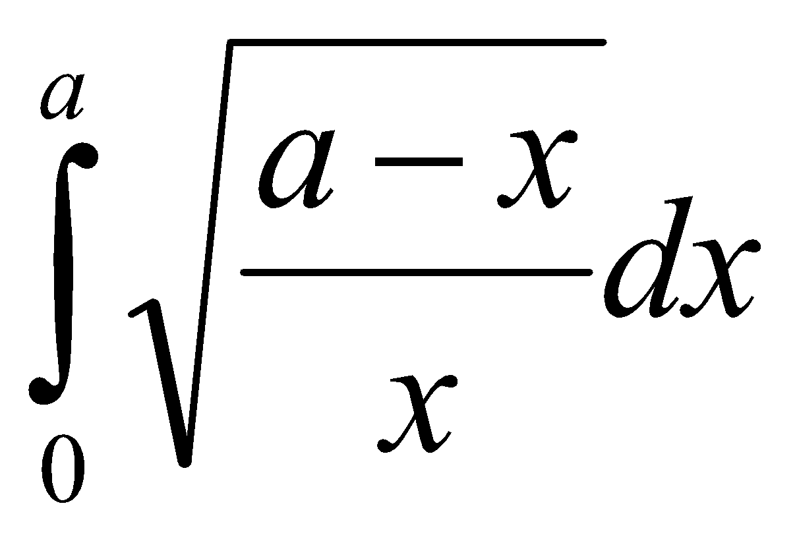

(d) Obtained the reduction formula for 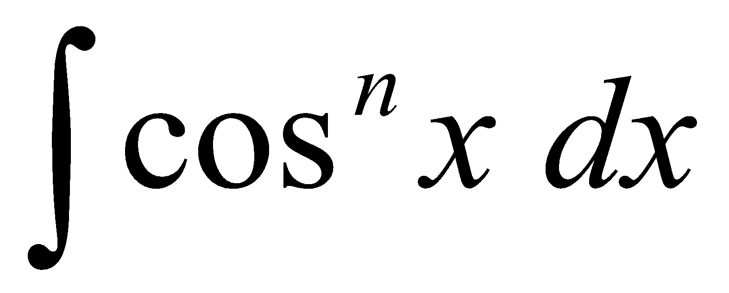 and then evaluate 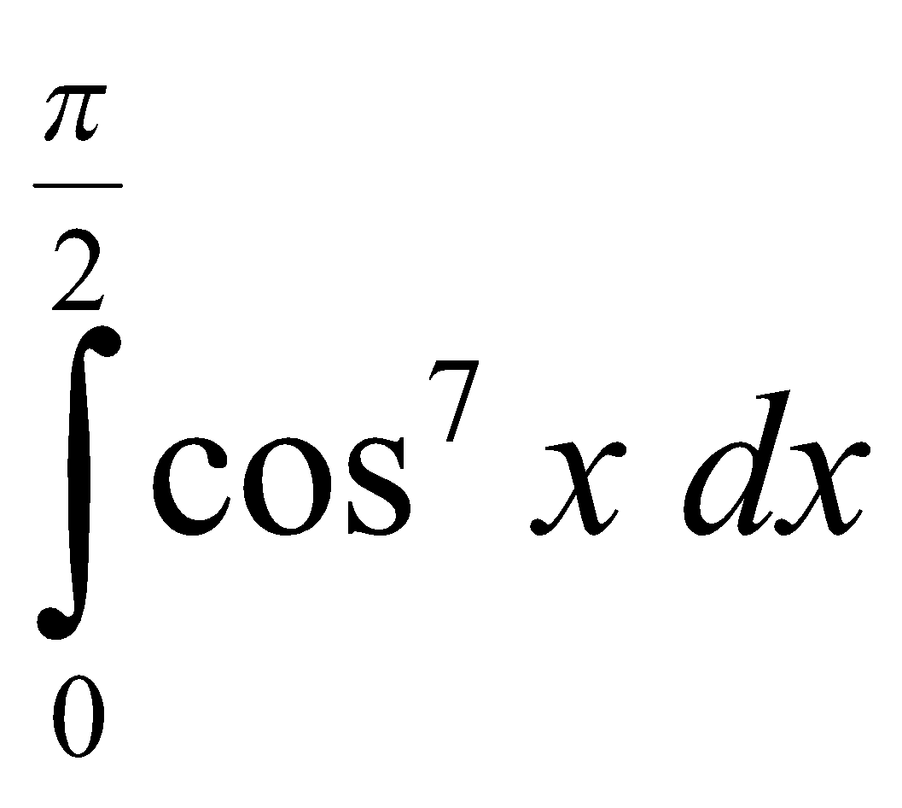

(4)a. Find the volume of solid generated by revolving the asteroid 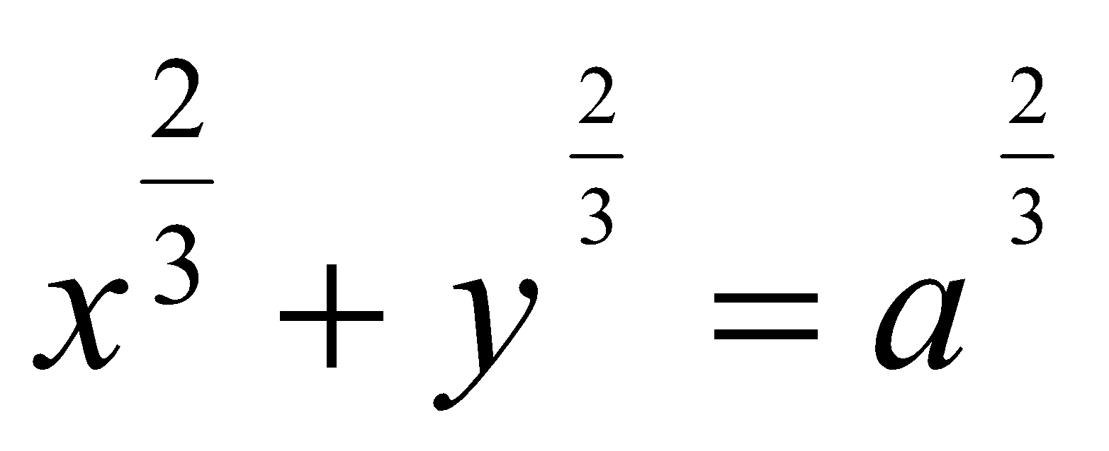 [8]

b. Find the arc of the parabola 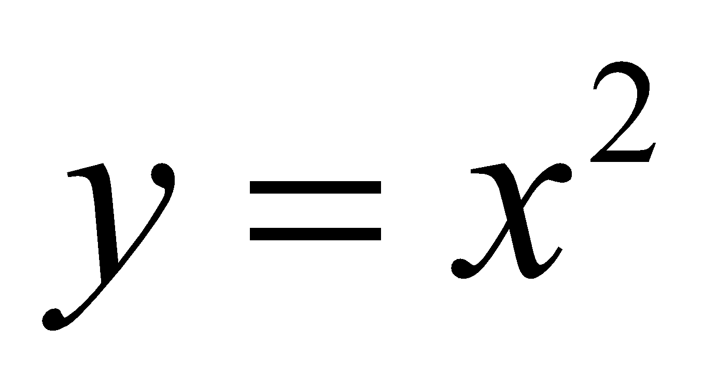 from (1,2) to (2,4) is roated about the y –axis find the area of resulting surface. [7]

(5)(a) State and proof Eulers theorem for the homogeneous function of two variable. Verify If 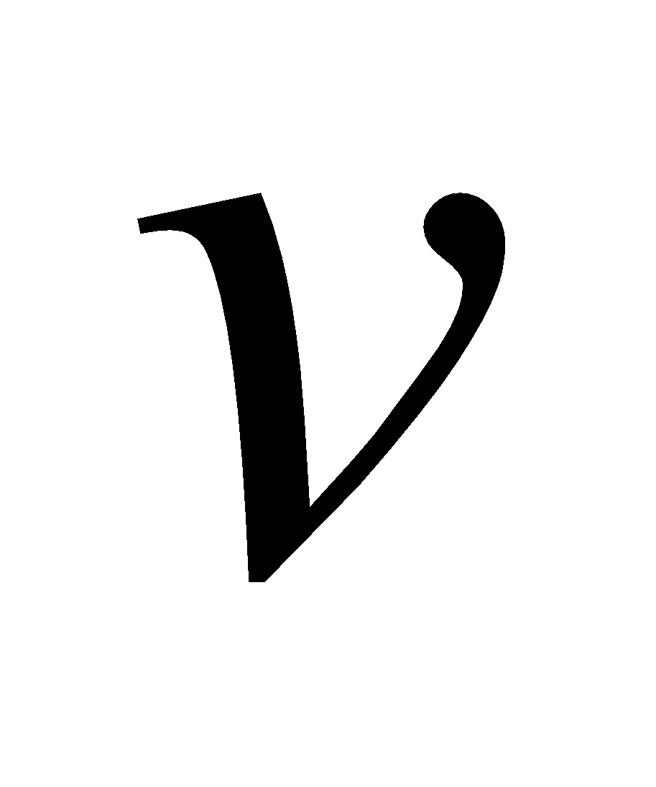=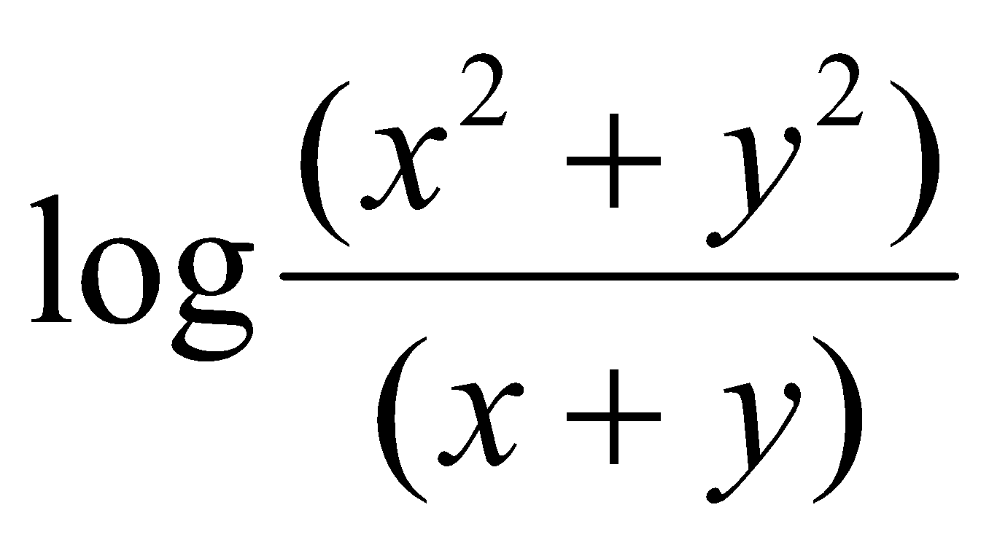 prove that 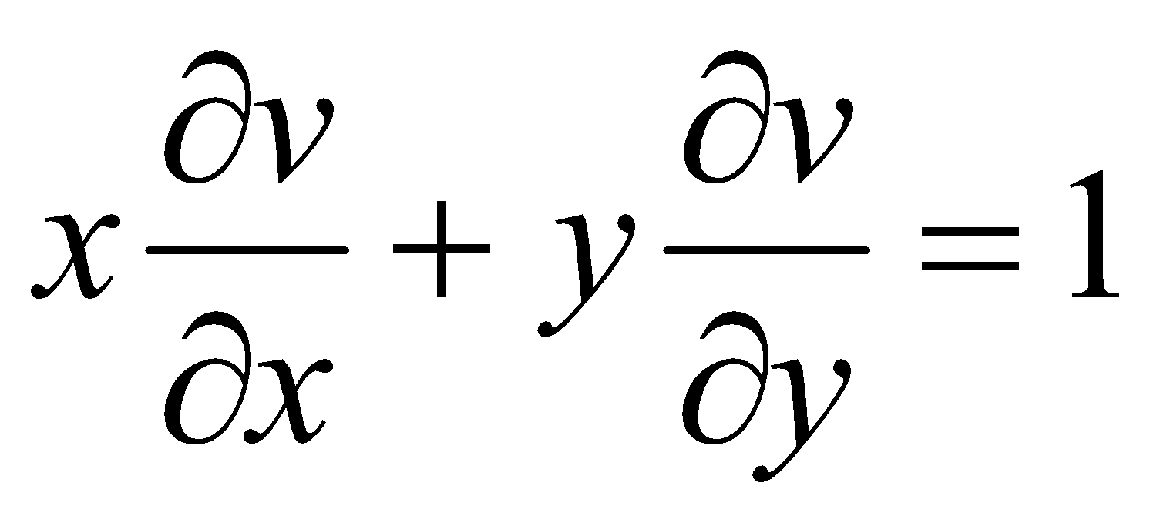 [8]

(b) find the extreme value of 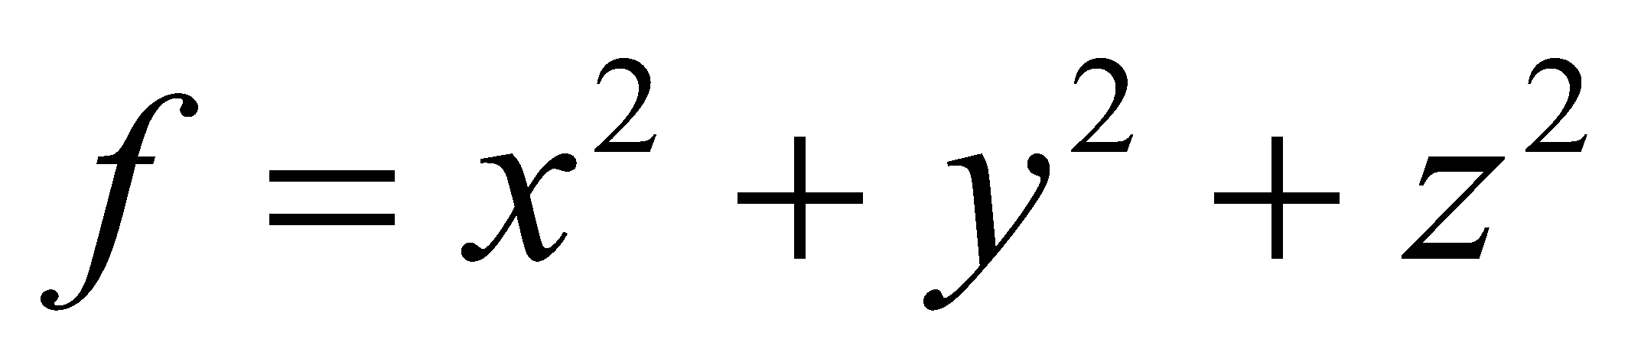 such that 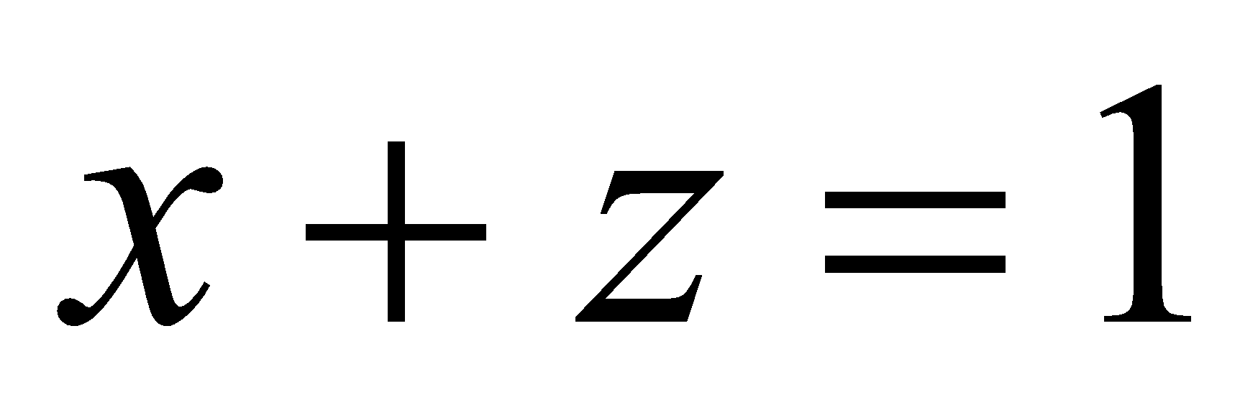 and 2y+z=2. [7]

(6) (a) solve: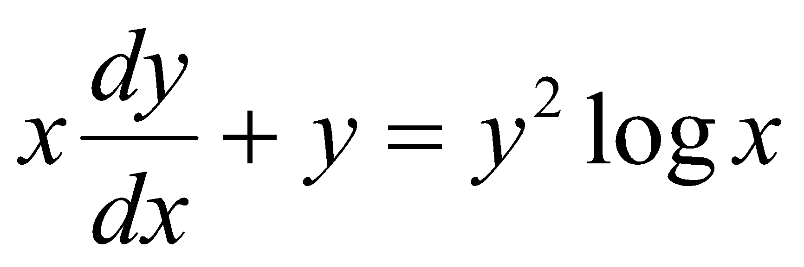 [7]

(b) solve 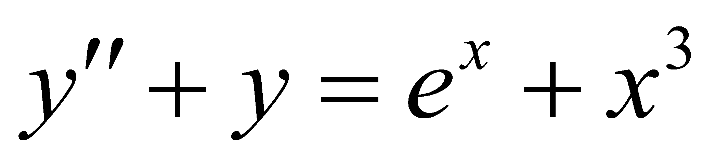 ,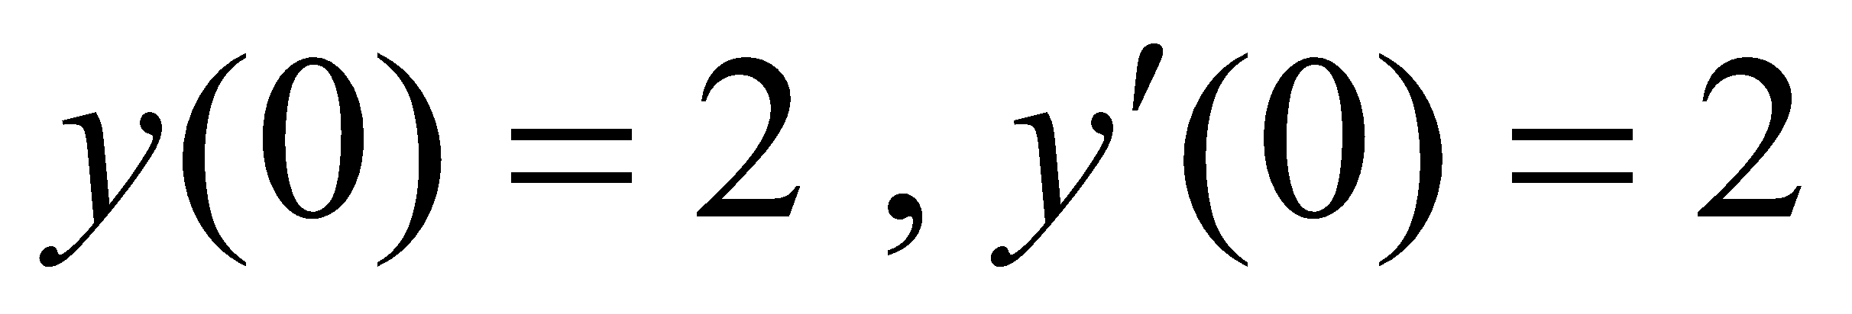 [8]

7. short question

(a)solve 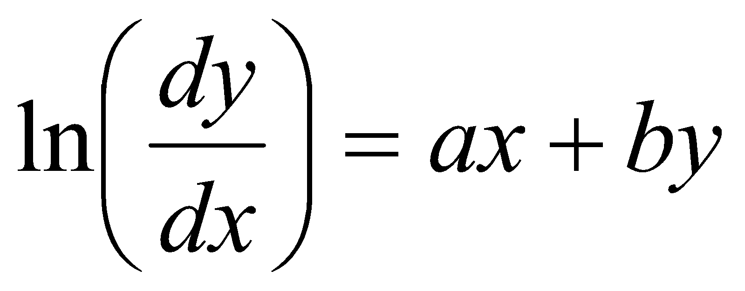

(b) solve 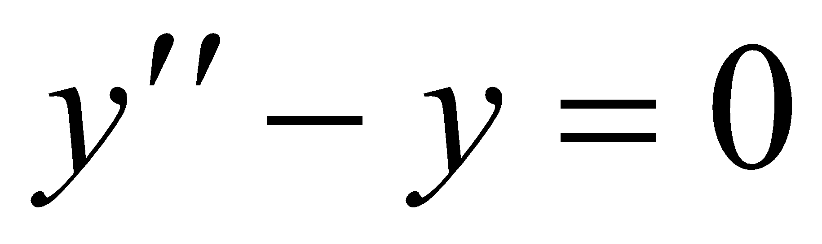

(c) solve 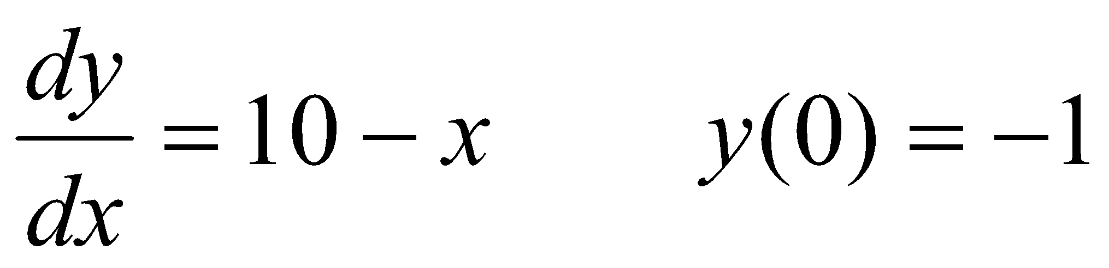

(d) Define differential equation with examples.